**CERTIFICATES OF DEPOSIT (CDs)**

**Introduction:**

Certificates of Deposit (CDs) have long been a popular savings instrument in the United States, valued for their safety and predictability. Offered by banks and credit unions, CDs provide a fixed interest rate for a specified term, in exchange for the depositor's commitment to leave their money untouched until the maturity date. This financial product appeals to risk-averse investors seeking stable returns, as CDs are typically insured by the Federal Deposit Insurance Corporation (FDIC) up to $250,000 per depositor, per insured bank, for each account ownership category.

Over the past five years, the landscape of CD rates has been shaped by various economic factors, including interest rate policies set by the Federal Reserve, market conditions, and broader economic events such as the COVID-19 pandemic. The period from 2019 to 2023 has been particularly illustrative of how external economic forces can impact fixed-income investment instruments like CDs.

In 2019, CD rates were relatively robust, reflecting a stable economic environment. However, the onset of the pandemic in early 2020 triggered a series of interest rate cuts by the Federal Reserve aimed at stimulating the economy, which led to a significant decline in CD rates. This decline continued through 2021, marking a challenging period for savers seeking higher yields. As the economy began to recover and inflationary pressures emerged, CD rates started to rise again in 2022 and 2023.

Understanding the trends and fluctuations in CD rates over this period provides valuable insights into the dynamics of fixed-income investments and the broader economic environment. This analysis not only helps savers and investors make informed decisions but also sheds light on the interplay between monetary policy, economic events, and interest rates

**Key Features of CDs:**

**1. Fixed Interest Rate:**

- CDs offer a guaranteed interest rate, which is typically higher than that of regular savings accounts.

- The rate remains unchanged for the term of the CD, regardless of market fluctuations.

**2. Fixed Term:**

- CD terms can range from a few months to several years.

- Common terms include 3, 6, 12, 24, 36, 48, and 60 months.

**3. Minimum Deposit Requirements:**

- Banks usually require a minimum deposit to open a CD, which can vary from $500 to $10,000 or more.

**4. Early Withdrawal Penalties:**

- If you withdraw your money before the CD matures, you’ll incur a penalty, often a portion of the interest earned.

- The penalty terms are defined by the bank at the time of the CD agreement.

**5. FDIC Insurance:**

- CDs at FDIC-insured banks are protected up to $250,000 per depositor, per insured bank, for each account ownership category.

**Types of CDs:**

**1. Traditional CD:**

- Offers a fixed interest rate for a fixed term.

**2. Jumbo CD:**

- Requires a large minimum deposit, usually $100,000 or more, and often offers higher interest rates.

**3. Bump-Up CD:**

- Allows you to “bump up” to a higher interest rate if the bank’s rates increase during the CD’s term.

**4. Step-Up CD:**

- The interest rate increases at predetermined intervals.

**5. No-Penalty CD:**

- Allows you to withdraw your money before the maturity date without incurring a penalty.

**6. Brokered CD:**

- Sold through brokerage firms and can be traded on the secondary market before maturity.

**Choosing a CD:**

When selecting a CD, consider the following factors:

**1. Interest Rate:**

- Compare rates from different banks to find the most competitive offer.

**2. Term Length:**

- Choose a term that aligns with when you might need access to your funds.

**3. Minimum Deposit:**

- Ensure you can meet the minimum deposit requirement.

**4. Early Withdrawal Penalty:**

- Understand the penalty terms in case you need to access your funds early.

**Benefits of CDs:**

**- Safety:** CDs are a low-risk investment due to FDIC insurance.

**- Predictability:** Fixed interest rates and terms provide predictable returns.

**- Higher Interest Rates:** Typically offer better rates than regular savings accounts.

**Drawbacks of CDs:**

**- Limited Liquidity:** Funds are locked in for the term of the CD.

**- Penalty for Early Withdrawal:** Can be significant if you need access to your money before the CD matures.

**- Fixed Rates:** In a rising interest rate environment, your money is locked in at a lower rate.

**CD Rates (2019-2023)**

|  |  |  |  |
| --- | --- | --- | --- |
| **Year** | **1-Year CD Rate (%)** | **3-Year CD Rate (%)** | **5-Year CD Rate (%)** |
| 2019 | 1.5 | 1.8 | 2.0 |
| 2020 | 0.9 | 1.1 | 1.3 |
| 2021 | 0.6 | 0.8 | 1.0 |
| 2022 | 0.8 | 1.0 | 1.2 |
| 2023 | 1.2 | 1.5 | 1.8 |

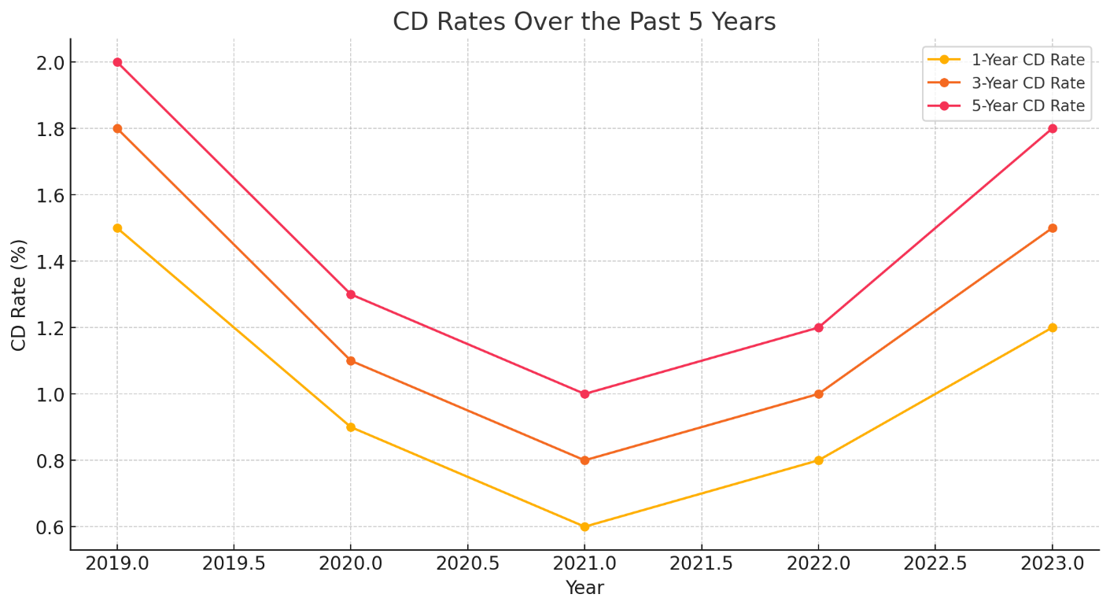

The graph depicts the trends in CD rates from 2019 to 2023 for 1-Year, 3-Year, and 5-Year terms. All three CD rates show a significant decline in 2020 and 2021, likely due to the economic downturn caused by the COVID-19 pandemic. The rates begin to recover in 2022, with a noticeable increase in 2023. Throughout the period, 5-Year CDs consistently offer the highest rates, followed by 3-Year CDs, and then 1-Year CDs. This suggests longer-term CDs provide better returns, reflecting the typical risk-reward trade-off in fixed-income investments.

**Conclusion**

The analysis of CD rates from 2019 to 2023 offers a comprehensive view of how macroeconomic factors influence savings instruments in the United States. The significant decline in CD rates during 2020 and 2021 can be attributed to the Federal Reserve's monetary policy responses to the COVID-19 pandemic, which aimed to mitigate economic downturns by lowering interest rates. This period underscored the sensitivity of fixed-income investments to broader economic conditions and policy decisions.

As the economy began to stabilize and grow in 2022, coupled with rising inflationary concerns, the Federal Reserve adjusted its stance, leading to an increase in interest rates. Consequently, CD rates started to recover, reflecting the improved economic outlook and higher inflation expectations. By 2023, CD rates had risen significantly, offering better returns for savers who opted for longer-term CDs.

This five-year period highlights the importance of understanding the economic context when investing in CDs. Savers must be cognizant of the potential for rate fluctuations and the impact of external economic factors on their returns. The period also illustrates the trade-off between the safety and stability of CDs and the need for flexibility in managing liquidity, particularly during times of economic uncertainty.

Investors looking to optimize their savings strategies should consider diversifying their fixed-income portfolios and staying informed about economic trends and monetary policies. By doing so, they can better navigate periods of low interest rates and capitalize on opportunities when rates rise.

In conclusion, while CDs remain a secure and predictable investment option, their attractiveness is closely linked to the prevailing economic environment. Understanding the trends over the past five years provides a valuable framework for anticipating future movements and making informed investment decisions. This knowledge equips investors to balance the benefits of security with the potential for higher returns, ensuring their savings strategies align with their financial goals and risk tolerance.